DEPLOYING A CONTAINERIZED APP USING KUBERNETES

Prerequisites
- A VPS
- A domain
- A website

1.SETTING UP A DOMAIN
What is a domain name system?
Computers communicate with IP addresses.
Human beings are not good with numeric values.
Therefore, DNS translates user-friendly domain names like: https://giktekkyc.org/ to numeric IP addresses that computers use to communicate (64.23.230.13).

What is a domain register?
It is a company authorized to manage and sell domain names.
https://www.namecheap.com/
This is where we bought the domain name.
After buying the domain in our dashboard/advanced DNS we must point our vps to our domain.
  - Create two A Records
  - Set one record’s to @ the other to www
  - Set the address to your VPS’s IP address i.e, 64.23.230.13
  - May take 24 to 48 hours to reflect

NGINX
What is nginx?
It is a web server that can be used as a reverse proxy.
How to install nginx?
- nginx can be installed differently, depending on the operating system.
- Our vps is running Linux(ubuntu) and in this case we will use nginx packages from:
https://nginx.org/en/linux_packages.html#Ubuntu
- The link above gives a detail description of installing the prerequisites and importing an
official nginx signing key so apt could verify the packages authenticity.
- There after run the following commands to install nginx
sudo apt update
sudo apt install nginx
sudo systemctl start nginx

- It is at the nginx where we register the domain name too. It is listed in the following path
/etc/nginx/conf.d/default.conf

2. INSTALLING TLS CERTIFICATE
What is a TLS certificate?
It is a Transport Layer Security) certificate previously referred to as an SSL (Secure Security Layer) certificate.
It verifies the identity of a website and encrypts the data transmitted between the User’s browser and the website.
What is Certbot?
Certbot is a free, open source software tool for automatically using Let’s Encrypt certificates on manually-administered websites to enable HTTPS.
Using the link below follow the steps listed in the documentation to install certbot.
https://certbot.eff.org/instructions?ws=nginx&os=snap&tab=standard

3.CREATING A CLUSTER

A cluster is a group of machines running your app. A kubernetes cluster consists of two parts:
- A control plane: It has several jobs. It stores your desired state, acts as a communication between the user(DevOps engineer) and the cluster. The user can check how the pods are doing, add or delete a deployment. It decides which pod goes to which node.
- Worker node: The worker node is where your pods are running. The kubelet checks the health of the node and pods, tells the api server to add or restart a pod.

A pod refers to a one or more running containers having the same internal IP, and sharing the same resources like volumes.
Think of node as a server or a machine.

The first thing we need to do to automate the deployment of our containers, is creating a cluster.

Components.
To create a cluster we need a few components:
- kubeadm:
This is a kubernetes tool we use to create clusters by simply running a command.
- “kubeadm init --config=kubeadm-config.yaml” (we will see this in the future)

- A Container Runtime(Docker):
We will need a tool to run our containers in our case its Docker.

- kubectl:
This is a command-line interface that allows the DevOps engineer to talk to the cluster. Using this CLI, we add and remove pods.

- kubelet:
Kubelet is a critical tool has to be installed in each worker node. It uses Docker to run its containers, sends the health status of the node and pods to the control plane so that it can match the desired state.

- Container Networking Interface:
CNI is a software we use to set up networking for containers. It is responsible for assigning unique IP addresses to each pod and also ensures pods can communicate with other pods as well as the outside world.

Prerequisites
- A VPS with at least 2 CPUs.
- A containerized application.

Steps
- Install Docker:
Visit this site and follow the instructions to install Docker.

- Turning swap off:
Kubernetes expects predictable memory behaviour. Disabling swap specifies the exact RAM available. To disable swap, run:
sudo swapoff -a
sudo sed -i ‘/ swap / s/^/#/’ /etc/fstab

- Turn ipv4 packet forwarding on:
Think of packet forwarding like sending and receiving letters. In the context of text packet forwarding refers to sending and receiving (packets) between network interfaces.
By default Linux does not allow packet forwarding so we have to turn it on so that pods can communicate with each other and the outside world. We make this possible by running:
Kubernetes link
cat <<EOF | sudo tee /etc/sysctl.d/k8s.conf
net.ipv4.ip_forward = 1
EOF
sudo sysctl --system

- Load kernel module dependencies:
echo -e "overlay\nbr_netfilter" | sudo tee /etc/modules-load.d/k8s.conf
sudo modprobe overlay: Sets a base image for all containers but maintains layers for file changes
sudo modprobe br_netfilter: Allows traffic between pods pass through Linux firewalls.
- Custom DNS:
Domain Name System is a process computers use to translate domain names to IP addresses. Kubernetes uses this for communication between pods, containers, nodes and external traffic. Systemd-resolved is a tool on Linux that handles DNS configuration for the whole system. It uses nameservers to translate domains.

It automatically adds nameservers to a file “/etc/resolv.conf” from other network interfaces like coredns(Kubernetes DNS’s config). coredns uses reads nameservers from this file that systemd-resolved adds to. The problem with this is that systemd-resolved does not have a limit on the nameservers to add but kubernetes has a limit of 3 nameservers that CNI uses for networking.

Because of this we will mask systemd-resolved (disable it essentially) and create our own “/etc/resolv.conf”. We will do so in the following steps:
- Run: sudo systemctl mask systemd-resolved: to mask(disable) systemd-resolved preventing it from adding nameservers to the file.
- sudo rm /etc/resolv.conf: To delete the existing file
- sudo nano /etc/resolv.conf: Create the file and add the following:
nameserver 8.8.8.8
nameserver 8.8.4.4

- CTRL+X > Y > “Enter” to save.
- sudo chattr +i /etc/resolv.conf: To lock the file, preventing any other program from modifying it.

- Configure Cgroup for Docker:
Control groups monitor and manage resources allocated to processes. In our case, we specify the RAM a particular pod may use.
Cgroup drivers facilitate this. “systemd” cgroup driver is the recommended driver to use. We must configure both Docker and kubelet to use the same cgroup driver. For Docker, we install cri-dockerd by running the following commands:
- wget https://github.com/Mirantis/cri-dockerd/releases/download/v0.3.17/cri-dockerd_0.3.17.3-0.debian-bookworm_amd64.deb
- sudo apt install ./cri-dockerd_0.3.17.3-0.debian-bookworm_amd64.deb

- Install kubelet, kubeadm, kubectl:
Install apt-transport-https, ca-certificates, cutl, gpg packages
  - sudo apt-get update
  - sudo apt-get install -y apt-transport-https ca-certificates curl gpg

Download the public signing key for the Kubernetes package repositories
  - curl -fsSL https://pkgs.k8s.io/core:/stable:/v1.30/deb/Release.key | sudo gpg --dearmor -o /etc/apt/keyrings/kubernetes-apt-keyring.gpg

Add the apt repository for Kubernetes 1.30
  - echo 'deb [signed-by=/etc/apt/keyrings/kubernetes-apt-keyring.gpg] https://pkgs.k8s.io/core:/stable:/v1.30/deb/ /' | sudo tee /etc/apt/sources.list.d/kubernetes.list

Install kubelet, kubectl, kubeadm
  - sudo apt-get update
  - sudo apt-get install -y kubelet kubeadm kubectl
  - sudo apt-mark hold kubelet kubeadm kubectl
  - sudo systemctl enable kubelet

- Initialize a kubernetes cluster:
We could just run “kubeadm init” but there are a few configurations like specifying cgroup drivers, cri-socket etc that we need to specify, so we can generate a default config file then customize it’s settings before initializing our cluster.
  - kubeadm config print init-defaults > kubeadm-config.yaml to generate the file first.
  - Configure settings as follows. (Hii Waonyesha)
  - Make sure cri-docker is running: sudo systemctl start cri-docker
  - After editing the file you can initialize your cluster by running:
    - sudo kubeadm init --config=kubeadm-config.yaml
- Install CNI plugin:
Now that we have a cluster, we must add a CNI plugin for network trafficking i.e Flannel. To add Flannel as our CNI plugin, go to their github re187.55.229.66po and follow the instructions to install.

Run :
kubectl get pod -A to check whether all current pods are running, especially flannel
pod.
If all pod status is Running, you can go ahead and add the manifests!

Deleting a cluster
In case you mess up and want to start again run the following command to completely remove every cluster related thing in your cluster:

sudo kubeadm reset --cri-socket=unix:///var/run/cri-dockerd.sock

sudo rm -rf /etc/cni /opt/cni /etc/kubernetes /var/lib/cni /var/lib/kubelet /etc/systemd/system/kubelet.service.d /var/run/kubernetes

4.INGRESS

Ingress is a resource we use when we want access our cluster externally. To help route to specific a service using Ingress, we need three things:
- An Ingress rule: Steps defining the path, path type, for a particular backend service
- An Ingress resource: The YAML file where we write our Ingress rules.
- An Ingress controller: Acts a bridge between the Ingress resource we wrote and the locally installed nginx

Steps
- Install ingress-nginx controller:
Visit this site for instructions on how to install.

- Edit the ingress-nginx-controller:
Once ingress-nginx controller, installed, edit the ingress-nginx-controller from LoadBalancer to NodePort:
kubectl edit svc ingress-nginx-controller -n ingress-nginx

Press “i” to enter edit mode, at the very bottom of the file, change
type: LoadBalancer to type: NodePort.
Press esc and type :wq once you’re done.
Now that we’ve edited our service, we can create deployments and services and ingresses to access our pods.

To orute requests to services we can either:
1. Use Ingress
We do this by editing our nginx config file as follows:
location / {
proxy_pass http://<VPS Public IP>:<Ingress nginx controller NodePort>;
proxy_set_header Host $host;
proxy_set_header X-Real-IP $remote_addr;
}

Or

2. Route each NodePort service
For each NodePort service, we’ll need to alter our NGINX default.conf (/etc/nginx/conf.d/default.conf) to route to that service, an example:

location /{route} {
proxy_pass http://<VPS Public IP>:<NodePort>;
proxy_set_header Host $host;
proxy_set_header X-Real-IP $remote_addr;
}

To reflect changes, run:
sudo nginx -t
sudo systemctl restart nginx

5. APPLYING MANIFESTS
Prerequisites
Before applying Kubernetes manifests, ensure:
- The Kubernetes cluster is up and running.
- You have kubectl configured and connected to the cluster.
- Docker images for each service are built and pushed to a container registry (e.g., Docker Hub).
- Networking and CNI (e.g., Calico) is configured correctly.
- The containerized application architecture is defined (services, dependencies, communication).
Understanding Key Kubernetes Objects
Deployment
A Deployment in Kubernetes is used to manage the lifecycle of your application containers. It's like setting up automatic backup for your website — if one copy fails, Kubernetes replaces it automatically. It ensures that the desired number of pod replicas are running at all times.
Creating a deployment
The following is an example of a Deployment. It creates a ReplicaSet to bring up three nginx Pods:
apiVersion: apps/v1
kind: Deployment
metadata:
name: nginx-deployment
labels:
app: nginx
spec:
replicas: 3
selector:
matchLabels:
app: nginx
template:
metadata:
labels:
app: nginx
spec:
containers:
- name: nginx
image: nginx:1.14.2
ports:
- containerPort: 80
In this example:
1. apiVersion: apps/v1 - This tells Kubernetes what version of its API you're using.
2. kind: Deployment - This tells Kubernetes what kind of thing you want to create. A Deployment is used when you want Kubernetes to keep a certain number of identical apps (called Pods) running. If one goes down, Kubernetes will start a new one.
3. Metadata –
(i)name: This is the name of your Deployment — you can use it to refer to this setup later.
(ii) labels: These are tags to help identify and group related parts. Here, we’re tagging this with app: nginx.
4. spec –
replicas: You want 3 copies of your app running at the same time — Kubernetes will make sure 3 are always up.
4. selector.matchLabels -this tells Kubernetes which Pods to look after — in this case, it will look for any Pods labeled app: nginx. This makes sure the Deployment manages only the Pods with that label.
5. Template - This is the blueprint for the Pods that will be created. It describes what the pods created by the deployment will look like
6. template.spec.containers - This section says what to run inside each pod. In here,you define which image and which port will be used to create this pod.
(i) name: A name for this container.
(ii) image: The container image to use. This one uses nginx, a web server, with version 1.14.2.
(iii) ports: This container listens on port 80, which is the default for websites (HTTP).

Service
A Service acts like a permanent address for your Pods. Everytime you create a pod,it gets a new IP address,if the pod crashes and restarts ,it gets a new IP . So you can’t rely on a pod directly and that’s where service comes in.Even if the Pods change, the Service stays the same and knows how to find the right Pods using labels.
The following is an example of a service:
apiVersion: v1
kind: Service
metadata:
name: my-service
spec:
selector:
app.kubernetes.io/name: MyApp
ports:
- protocol: TCP
port: 80
targetPort: 9376

1.apiVersion: v1- This says what version of the Kubernetes API you're using.
2. kind: Service - This tells Kubernetes the type of object you are creating. Here, it's a Service, which allows you to expose and connect to Pods.
3. metadata - name: The name of the Service.
4. selector - This tells the Service which Pods to connect to, based on their labels.
5. ports –
(i) protocol: TCP: Most web traffic uses TCP.
(ii) port: 80: This is the port the Service listens on
(iii) targetPort: 9376: This is the port inside the Pod where traffic should be sent.
Service Types
1.ClusterIp - Choosing this value makes the Service only reachable from within the cluster.You use it when you don’t need external access.eg
2.NodePort – Exposes the Service outside the cluster using a port on each Node’s IP address.Kubernetes assigns a port from range (30000-32767).
You access it from outside the cluster by http://<NodeIP>:<NodePort>
3.LoadBalancer – It Creates a cloud provider’s external load balancer (like AWS ELB, GCP LB).
· Automatically assigns a public IP address.
· Forwards external traffic to the internal Pods.
· You access it from the internet using a clean public IP or domain
· You use it when You’re deploying on cloud platforms and want easy, direct internet access. e.g.
Applying Kubernetes Manifests
To apply any YAML file, use: kubectl apply -f <filename>.yaml
You can apply multiple files at once with: kubectl apply -f .

The following are the actual YAML files used :
1.kyc-frontend-deployment.yaml
Purpose: Deploys the main user-facing web interface for the KYC web app.
apiVersion: apps/v1
kind: Deployment
metadata:
name: frontend
labels:
app: kyc-frontend
spec:
replicas: 2
selector:
matchLabels:
app: kyc-frontend
template:
metadata:
labels:
app: kyc-frontend
spec:
containers:
- name: frontend
image: cecillwala/kyc-frontend
ports:
- containerPort: 80

---

apiVersion: v1
kind: Service
metadata:
name: frontend
spec:
type: NodePort
selector:
app: kyc-frontend
ports:
- protocol: TCP
port: 80

---

apiVersion: v1
kind: Service
metadata:
name: frontend-internal
spec:
type: ClusterIP
selector:
app: kyc-frontend
ports:
- protocol: TCP
port: 80
Deployment Explanation
Breakdown:
· apiVersion: Uses the stable API version for Deployments.
· kind: This is a Deployment, meaning Kubernetes will manage the lifecycle of your app Pods.
· metadata.name: The name of the Deployment is frontend.
apiVersion: apps/v1
kind: Deployment
metadata:
name: frontend
labels:
app: kyc-frontend
spec:
replicas: 2
selector:
matchLabels:
app: kyc-frontend
template:
metadata:
labels:
app: kyc-frontend
spec:
containers:
- name: frontend
image: cecillwala/kyc-frontend
ports:
- containerPort: 80

· metadata.labels: Labels help identify this Deployment and match it to other objects.
· spec.replicas: This ensures 2 instances (Pods) of the app run at all times.
· spec.selector.matchLabels: Tells the deployment which pods it owns based on labels
· spec.template: This is the blueprint for the Pods that the Deployment will create.
o metadata.labels: Pods created will be labelled with app:kyc-frontend
o spec.containers:Defines whats inside the pod
§ name: Container named frontend
§ image: Uses the Docker image cecillwala/kyc-frontend
§ containerPort: App inside the container listens on port 80.
Service Explanation (NodePort)
apiVersion: v1
kind: Service
metadata:
name: frontend
spec:
type: NodePort
selector:
app: kyc-frontend
ports:
- protocol: TCP
port: 80
Breakdown:
· apiVersion: Uses version v1 for basic Kubernetes objects.
· kind: This is a Service, a way to expose and connect to the app.
· metadata.name: The name of the Service is frontend.
· spec.type: NodePort exposes the app to the outside world on a port of each node.
· spec.selector: Finds all Pods labeled app: kyc-frontend and send traffic to them.
· spec.ports:
o protocol: Uses TCP, which is standard for web apps.
o port: The port that the Service listens on inside the cluster (usually 80).

Internal Service (ClusterIP)
apiVersion: v1
kind: Service
metadata:
name: frontend-internal
spec:
type: ClusterIP
selector:
app: kyc-frontend
ports:
- protocol: TCP
port: 80

Breakdown:
· kind: Another Service, but of type ClusterIP.
· type: ClusterIP makes this Service reachable only from inside the cluster.
· selector: Routes traffic to Pods with the label app: kyc-frontend.
· port: Listens on port 80.
Ø Create the pod by running the command:kubectl apply -f kyc-frontend-deployment.yaml
2.kyc-service-deployment.yaml
Purpose: Hosts the core logic for customer onboarding and KYC verification.
apiVersion: apps/v1
kind: Deployment
metadata:
name: kyc-service
labels:
app: kyc-service
spec:
replicas: 2
selector:
matchLabels:
app: kyc-service
template:
metadata:
labels:
app: kyc-service
spec:
containers:
- name: kyc-service
image: cecillwala/kyc-kyc-service
ports:
- containerPort: 8081

---

apiVersion: v1
kind: Service
metadata:
name: kyc-service-internal
spec:
type: ClusterIP
selector:
app: kyc-service
ports:
- port: 8081
targetPort: 8081

---

apiVersion: v1
kind: Service
metadata:
name: kyc-service
spec:
type: NodePort
selector:
app: kyc-service
ports:
- port: 8081
nodePort: 32068
targetPort: 8081

Ø Create the pod by running the command:kubectl apply -f .kyc-service-deployment.yaml
3.report-frontend.yaml
Purpose: Provides a UI dashboard to view reports and data generated by the KYC process.
apiVersion: apps/v1
kind: Deployment
metadata:
name: report-frontend
labels:
app: kyc-report-frontend
spec:
replicas: 2
selector:
matchLabels:
app: kyc-report-frontend
template:
metadata:
labels:
app: kyc-report-frontend
spec:
containers:
- name: report-frontend
image: stanleyotieno/kyc-report-front-end
ports:
- containerPort: 80

---

apiVersion: v1
kind: Service
metadata:
name: report-frontend
spec:
type: NodePort
selector:
app: kyc-report-frontend
ports:
- protocol: TCP
port: 80

Ø Create the pod by running the command:kubectl apply -f report-frontend.yaml

4.rabbitmq.yaml
Purpose: Deploys RabbitMQ, which handles asynchronous messaging between services.
apiVersion: apps/v1
kind: Deployment
metadata:
name: rabbitmq
spec:
replicas: 1
selector:
matchLabels:
app: rabbitmq
template:
metadata:
labels:
app: rabbitmq
spec:
containers:
- name: rabbitmq
image: rabbitmq:4.1.0-management
env:
- name: RABBITMQ_DEFAULT_USER
value: guest
- name: RABBITMQ_DEFAULT_PASS
value: guest
ports:
- containerPort: 5672
- containerPort: 15672
---
apiVersion: v1
kind: Service
metadata:
name: rabbitmq
spec:
selector:
app: rabbitmq
ports:
- name: amqp
port: 5672
targetPort: 5672
- name: management
port: 15672
targetPort: 15672
type: ClusterIP

Ø Create the pod by running the command:kubectl apply -f rabbitmq.yaml

5.report-service-deployment.yaml
Purpose: Handles the generation of KYC reports and analytics.
apiVersion: apps/v1
kind: Deployment
metadata:
name: report-service
labels:
app: kyc-report-service
spec:
replicas: 2
selector:
matchLabels:
app: kyc-report-service
template:
metadata:
labels:
app: kyc-report-service
spec:
containers:
- name: kyc-report-service
image: cecillwala/kyc-report-service
ports:
- containerPort: 8083

---

apiVersion: v1
kind: Service
metadata:
name: kyc-report-service
spec:
type: ClusterIP
selector:
app: kyc-report-service
ports:
- port: 8083
targetPort: 8083

---

apiVersion: v1
kind: Service
metadata:
name: report-service
spec:
type: NodePort
selector:
app: kyc-report-service
ports:
- port: 8083
nodePort: 31559
targetPort: 8083

Ø Create the pod by running the command:kubectl apply -f report-service-deployment.yaml
6.eureka-server-deployment.yaml
Purpose: Service discovery using Eureka. Other services register themselves here.
apiVersion: apps/v1
kind: Deployment
metadata:
name: eureka-server
labels:
app: kyc-eureka-server
spec:
replicas: 2
selector:
matchLabels:
app: kyc-eureka-server
template:
metadata:
labels:
app: kyc-eureka-server
spec:
containers:
- name: eureka-server
image: cecillwala/kyc-eureka-server
ports:
- containerPort: 9099

---

apiVersion: v1
kind: Service
metadata:
name: eureka-server
spec:
type: ClusterIP
selector:
app: kyc-eureka-server
ports:
- protocol: TCP
port: 9099
targetPort: 9099

---

apiVersion: v1
kind: Service
metadata:
name: eureka-server-external
spec:
type: NodePort
selector:
app: kyc-eureka-server
ports:
- protocol: TCP
port: 9099
nodePort: 30761
targetPort: 9099

Ø Create the pod by running the command:kubectl apply -f eureka-server-deployment.yaml

8.email-service-deployment.yaml
Purpose: Sends emails
apiVersion: apps/v1
kind: Deployment
metadata:
name: email-service
labels:
app: kyc-email-service
spec:
replicas: 2
selector:
matchLabels:
app: kyc-email-service
template:
metadata:
labels:
app: kyc-email-service
spec:
containers:
- name: kyc-email-service
image: cecillwala/kyc-email-service
ports:
- containerPort: 8082

---

apiVersion: v1
kind: Service
metadata:
name: kyc-email-service
spec:
type: ClusterIP
selector:
app: kyc-email-service
ports:
- port: 8082
targetPort: 8082

Ø Create the pod by running the command:kubectl apply -f email-service-deployment.yaml

9.api-gateway-yaml.yaml
Purpose: Routes external traffic to internal services
apiVersion: apps/v1
kind: Deployment
metadata:
name: api-gateway
labels:
app: kyc-api-gateway
spec:
replicas: 2
selector:
matchLabels:
app: kyc-api-gateway
template:
metadata:
labels:
app: kyc-api-gateway
spec:
containers:
- name: api-gateway
image: cecillwala/kyc-api-gateway
ports:
- containerPort: 8080

---

apiVersion: v1
kind: Service
metadata:
name: api-gateway
spec:
selector:
app: kyc-api-gateway
ports:
- protocol: TCP
port: 80
targetPort: 8080

apiVersion: v1
kind: Service
metadata:
name: api-gateway-external
spec:
type: NodePort
selector:
app: kyc-api-gateway
ports:
- protocol: TCP
port: 80
nodePort: 30080
targetPort: 8080
Ø Create the pod by running the command:kubectl apply -f api-gateway-yaml.yaml

Verifying Deployment:Use the following commands
- kubecl get pods
- kubectl get services
- kubectl get deployments

­­­­­

6.SETTING UP A DATABASE
We used PostgreSQL as our database. We used a PostgreSQL image. There are 5 steps to setting up a working database all highlighted in this documentation.

- Create PostgreSQL secret:
An example:
postgres-config.yaml
apiVersion: v1
kind: ConfigMap
metadata:
name: postgres-secret
labels:
app: postgres
data:
POSTGRES_DB: ps_db
POSTGRES_USER: ps_user
POSTGRES_PASSWORD: SecurePassword

NOTE:For each .yaml don’t forget to run “kubectl apply -f “file”.yaml”

- Create a persistent volume:
postgres-pv.yaml
apiVersion: v1
kind: PersistentVolume
metadata:
name: postgres-volume
labels:
type: local
app: postgres
spec:
storageClassName: manual
capacity:
storage: 10Gi
accessModes:
- ReadWriteMany
hostPath:
path: /data/postgresql

NOTE: If you already have some data in /data/postgresql, delete that data first (sudo rm -rf /data/postgresql)

- Create a Persistence Volume Claim:
postgres-pvc.yaml
apiVersion: v1
kind: PersistentVolumeClaim
metadata:
name: postgres-volume-claim
labels:
app: postgres
spec:
storageClassName: manual
accessModes:
- ReadWriteMany
resources:
requests:
storage: 10Gi

- Create a postgres deployment:
postgres.yaml
apiVersion: apps/v1
kind: Deployment
metadata:
name: postgres
spec:
replicas: 1
selector:
matchLabels:
app: postgres
template:
metadata:
labels:
app: postgres
spec:
containers:
- name: postgres
image: 'postgres:14'
imagePullPolicy: IfNotPresent
ports:
- containerPort: 5432
envFrom:
- configMapRef:
name: postgres-secret
volumeMounts:
- mountPath: /var/lib/postgresql/data
name: postgresdata
volumes:
- name: postgresdata
persistentVolumeClaim:
claimName: postgres-volume-claim

- Create a postgres service
postgres-service.yaml
apiVersion: v1
kind: Service
metadata:
name: postgres
labels:
app: postgres
spec:
type: ClusterIP
ports:
- port: 5432
selector:
app: postgres

7.PROMETHEUS

Prometheus & Grafana Setup Using Helm Charts
helm repo add grafana https://grafana.github.io/helm-charts

helm repo add prometheus-community https://prometheus-community.github.io/helm-charts
helm repo update

helm install monitoring prometheus-community/kube-prometheus-stack \
--version 70.1.1 \
-n monitoring \
--create-namespace \
-f values.yaml

helm install loki grafana/loki-stack \
--version 2.9.10 \
-n monitoring \
--set loki.service.type=NodePort \
--set loki.service.nodePort=32003 \
--set grafana.enabled=true \
--set promtail.enabled=true \
--set loki.resources.requests.memory=128Mi \
--set loki.resources.limits.memory=256Mi

For production with a separate values-loki.yaml
Apply the codes
helm install monitoring prometheus-community/kube-prometheus-stack \
--version 70.1.1 \
-n monitoring --create-namespace \
-f values-prom.yaml
helm install loki grafana/loki-stack \
--version 2.9.10 \
-n monitoring \
-f values-loki.yaml

UNINSTALLING PROMETHEUS && GRAFANA
helm uninstall monitoring -n monitoring
kubectl delete crd alertmanagerconfigs.monitoring.coreos.com
kubectl delete crd alertmanagers.monitoring.coreos.com
kubectl delete crd podmonitors.monitoring.coreos.com
kubectl delete crd probes.monitoring.coreos.com
kubectl delete crd prometheusagents.monitoring.coreos.com
kubectl delete crd prometheuses.monitoring.coreos.com
kubectl delete crd prometheusrules.monitoring.coreos.com
kubectl delete crd scrapeconfigs.monitoring.coreos.com
kubectl delete crd servicemonitors.monitoring.coreos.com
kubectl delete crd thanosrulers.monitoring.coreos.com
helm uninstall loki -n monitoring

Prerequisites
- A running Kubernetes cluster (minikube, EKS, GKE, etc.).
- kubectl configured to access the cluster.
- Helm (v3+) installed on your local machine.

Step 1: Add Helm Repositories

helm repo add prometheus-community https://prometheus-community.github.io/helm-charts
helm repo add grafana https://grafana.github.io/helm-charts
helm repo update

Step 2: Install Prometheus

Option A: Install with default values
bash
Copy code
helm install prometheus prometheus-community/prometheus

Option B: Install with custom values (recommended)
- Create a prometheus-values.yaml file:
server:
service:
type: NodePort

- Install using the custom values:
helm install prometheus -f prometheus-values.yaml prometheus-community/prometheus

Verify Prometheus Installation
kubectl get all -l app=prometheus
kubectl port-forward svc/prometheus-server 9090:80

Visit Prometheus dashboard: http://localhost:9090

Step 3: Install Grafana

Option A: Install with default values
helm install grafana grafana/grafana

Option B: Install with custom values
- Create a grafana-values.yaml file:
adminUser: admin
adminPassword: admin
service:
type: NodePort

- Install Grafana:
helm install grafana -f grafana-values.yaml grafana/grafana

Retrieve Grafana Password (if not set)
jsonpath="{.data.admin-password}" | base64 --decode

Access Grafana UI
kubectl port-forward svc/grafana 3000:80

Visit Grafana dashboard: http://localhost:3000
Login with:
- Username: admin
- Password: as retrieved above

Step 4: Connect Prometheus to Grafana
- Open Grafana in your browser.
- Go to Settings → Data Sources → Add data source.
- Select Prometheus.
In the URL field, enter:
http://prometheus-server.default.svc.cluster.local
- Click Save & Test.

Step 5: Import Dashboards
- In Grafana, go to Create → Import.
- Use dashboard IDs from Grafana Dashboards, e.g.:
  - Prometheus Stats: 2
  - Kubernetes Monitoring: 315

8.CI / CD

CI/CD enables us to automatically test and integrate code changes as soon as they are pushed. This ensures we always have a production ready code that can be deployed at any time.

CI - Continuous Integration
With CI , developers frequently commit to a shared common repository using Version Control(In our case we used Github).
For this you create a CI pipeline
Objectives:
- Run’s on every push/pull request to specific branches (in our case “main” and “dev”)
- Builds the project and run tests
- Builds docker images
- Pushes images to docker hub
- Triggers CD in a different repo
Prerequisites:
- Git repository with microservices
- Docker Hub account
- Github Secrets

CI pipeline automatically run builds, store artifacts and run unit tests . We can configure CI pipeline to be triggered every time an event occurs(e.g every time there is a commit /merge to a codebase.)

Project Structure Example
.
├── .github/
│ └── workflows/
│ └── ci.yml
├── kyc-service/
│ └── Dockerfile
├── api-gateway/
│ └── Dockerfile
├── README.md

Steps
Create a github workflow file.
Conventionally, it written at the root of the project repo ie .github/workflows/ci.yml

Below is an example using a real Spring Boot project

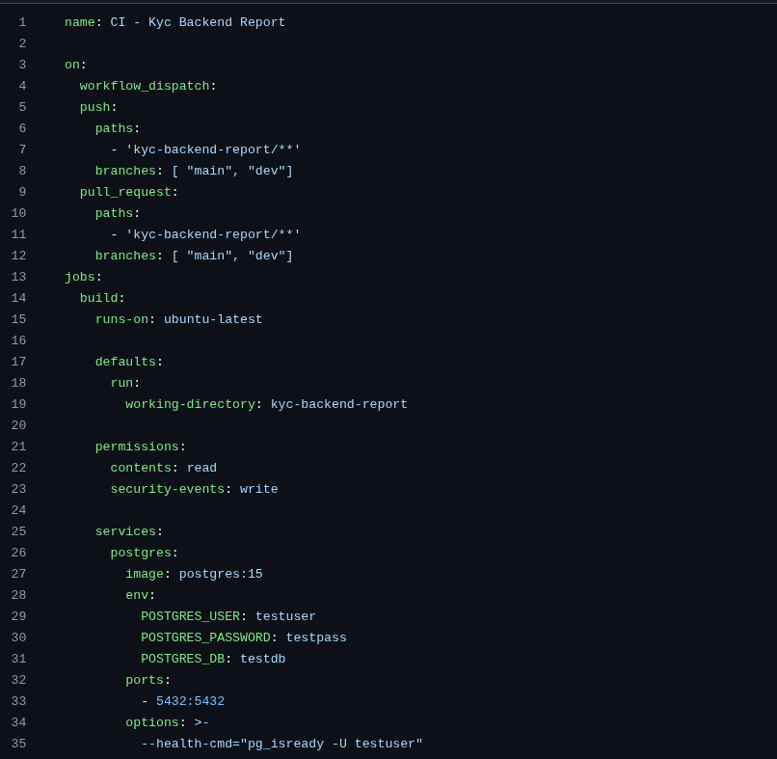

Continuation of the previous file

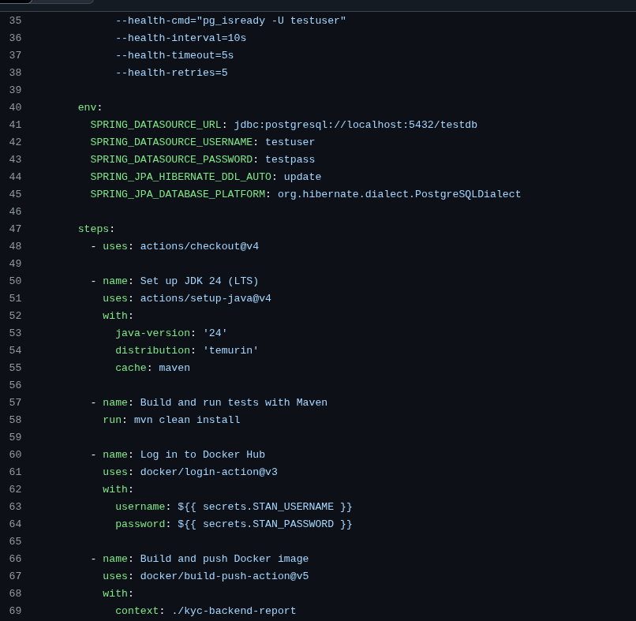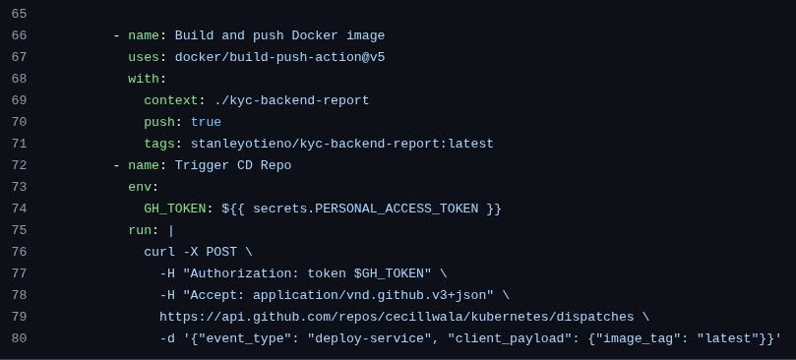

In our workflow:
- We specify that the workflow gets triggered when a change is pushed to the “main” and “dev” branches, on a specific path - /kyc-backend-report/**
- Jobs: This job runs on Github hosted Ubuntu-linux machine and it’s configured to run on kyc-backend-report/ folder by default. It uses read-only github token to access repository’s content.
This GitHub Actions workflow performs the CI process for the kyc-backend-report service. Here's what it does:
- Spins up a PostgreSQL 15 container for testing using GitHub's built-in services feature. It sets environment variables like database name, user, and password, and checks the database health using pg_isready.
- Defines environment variables for the Spring Boot application to connect to the PostgreSQL container during the build and test phase.
- Checks out the repository code to the runner.
- Sets up Java JDK 24 using the Temurin distribution and enables Maven caching for faster builds.
- Builds and runs tests using Maven to verify that the application compiles and passes all tests.
- Authenticates with Docker Hub using credentials stored in GitHub secrets.
- Builds and pushes a Docker image of the backend application to Docker Hub, tagged as latest.
- Triggers the CD (deployment) repository via a repository_dispatch event, informing it that a new Docker image is available for deployment.
To enable CD trigger we create an access token in github . Copy and paste the token as a secret variable in your repo (**/settings) section

CD
Continuous delivery / Continuous deployment
Continuous delivery
Help developers test their code in production similar environment to prevent post production surprises

Continuous Deployment
It extends continuous delivery by automating the deployment of every code change that passes tests directly to production , without manual approval

Example using a real project:
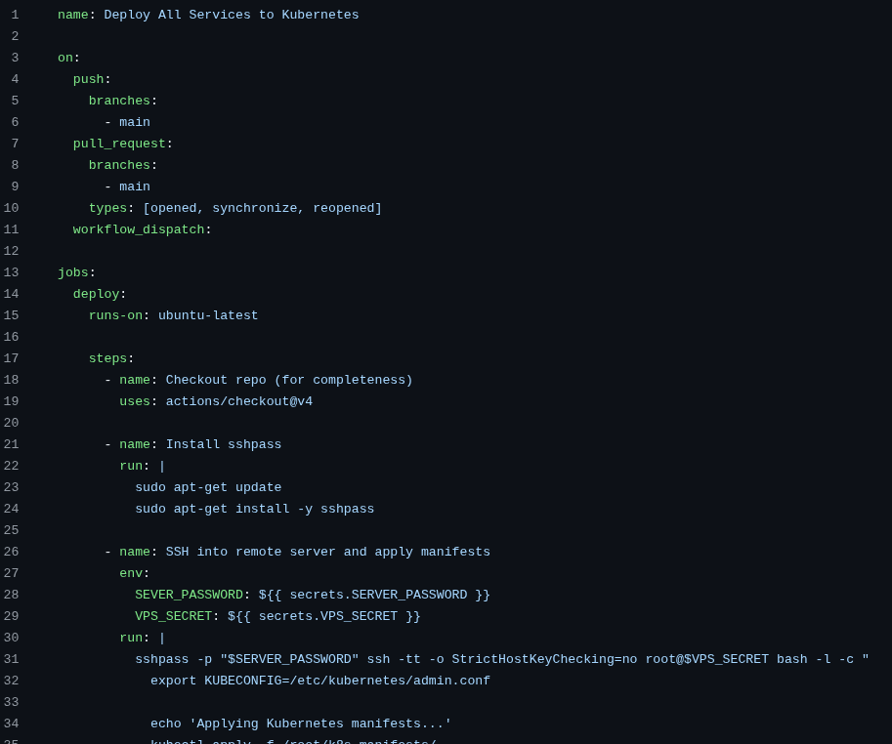
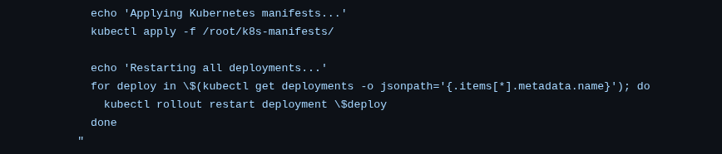

This GitHub Actions workflow automates the deployment of all Kubernetes services whenever changes are made to the main branch or a pull request targeting main is opened or updated. It ensures that your latest code changes are always reflected in your live Kubernetes environment.

🧩 Trigger Events
The workflow runs automatically on:
- Pushes to main branch
- Pull Requests targeting main (on open, update, or reopen)
- Manual triggers via GitHub UI (workflow_dispatch)
- External repository dispatch events of type deploy-service

⚙️ What the CD Does (In a Nutshell)
- Checks out the repo (useful for future steps, though not required in this case).
- Installs sshpass: Required for non-interactive SSH using passwords.
- SSHs into the remote VPS (not as root) using credentials stored securely in GitHub secrets.
- Applies all Kubernetes manifests from the remote /home/<user>/k8s-manifests/ directory.
- Restarts all running deployments to ensure new Docker image versions (if any) are picked up.

🛡️ Secrets Required
The deployment uses the following GitHub secrets:
- VPS_SECRET: The VPS's IP or domain.
- VPS_USER: The non-root Linux user on the VPS.
- VPS_USER_PASSWORD: The user's login password (used by sshpass for SSH).

location /grafana/ {
proxy_pass http://69.62.114.65:32000;
proxy_set_header Host $host;
proxy_set_header X-Real-IP $remote_addr;
proxy_set_header X-Forwarded-For $proxy_add_x_forwarded_for;
proxy_set_header X-Forwarded-Proto $scheme;
proxy_set_header X-Script-Name /grafana;
}
helm repo add grafana https://grafana.github.io/helm-charts

helm repo add prometheus-community https://prometheus-community.github.io/helm-charts
helm repo update

helm install monitoring prometheus-community/kube-prometheus-stack \
-n monitoring \
--create-namespace \
-f values.yaml

helm install loki grafana/loki-stack \
-n monitoring

